1. Write a Query to retrieve employees Name, Salary, and Commission
2. Find out those Employees who has commission
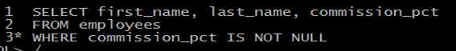
3. Find out those Employees who do not have commission
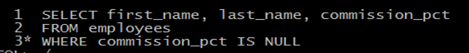
4. Find out Top 10 and least 10 salaried employees
1st step
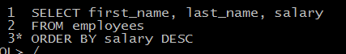
2nd step
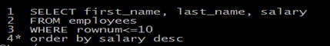

5. Find out employees yearly Salary with commission
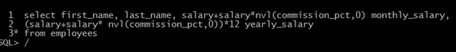
6-Find out those employees who get more than average Salary
1st step
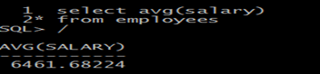
2nd step
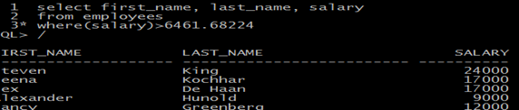
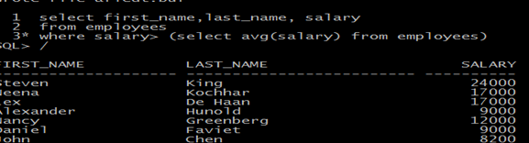

7. Find out the departments which do not have employees
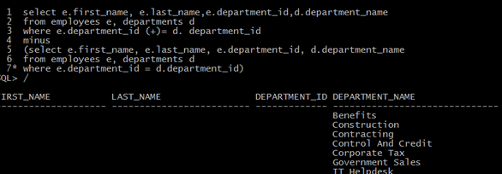
8. Find out those employees who does not belong to any Department
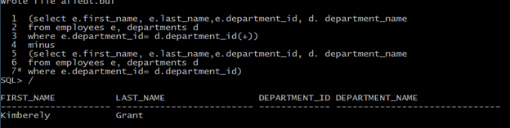
9. Find out managers of the employees
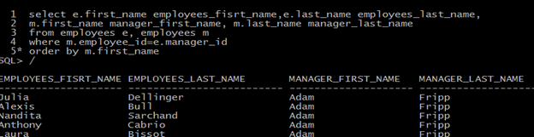

10. Find out employees average Salary
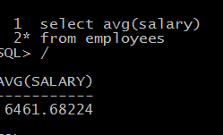
11. Find out employees average Salary within their Department
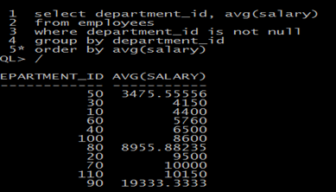

12. Find out employees average Salary greater than 10,000 within their Department
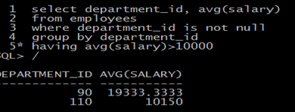

13. Find out those employees who get the same salary as Alexander Hunold.
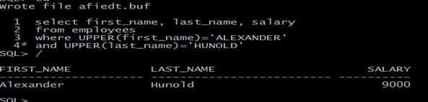
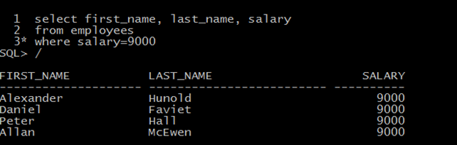
14. Write a SQL Query,
If’ job is IT_PROG, the Salary increases 10%
If job is FI_ACCOUNT, the Salary increases 15%
If job is ST_CLERK, the Salary increases 20%
If job is SA_REP, the Salary increases 25%
If job is AC_ACCOUNT, the Salary increases 30%
For all other roles, there is no increase Salary
select first_name,last_name,job_id, salary
Decode (job_id,'it_prog', salary*1.10,
'fi-account', salary*1.15,
'st_clark', salary*1.20,
'sa_rep', salary*1.25,
'ac_account', salary*1.30,
salary) increased_salary,
from employees
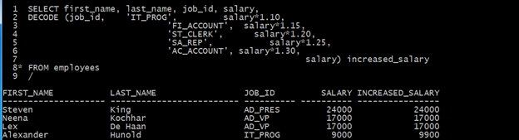

15. Display the number of Distinct Department in the Employee table

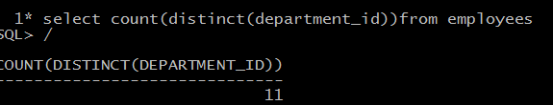
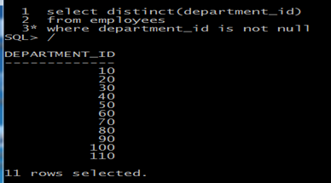

16. Find out who earns the maximum salary
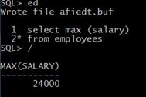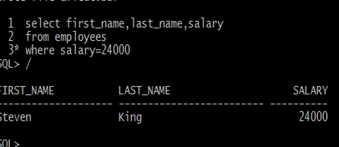
17. Find out those managers who manage only one employee
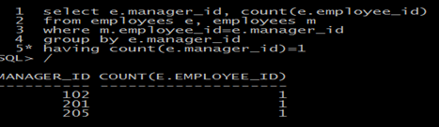
18. Create a Table with [your name] using Employee Table

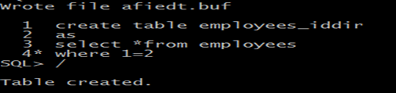

19. Insert a row in that Table you created
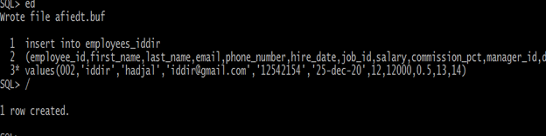
20. Create a text file, put 5 records, and execute it in the Command Line
21. Update a row with that Table you created
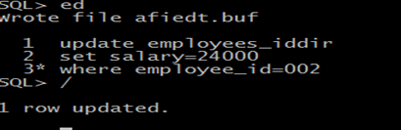
22. Delete a row from that Table you created
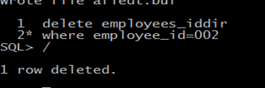
23. Write a Query to retrieve to display first 10 records
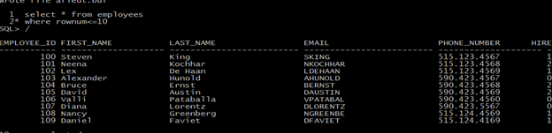

24. Write a Function to calculate employees Income Tax where Income Tax is .8625%
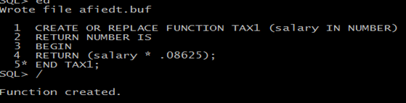
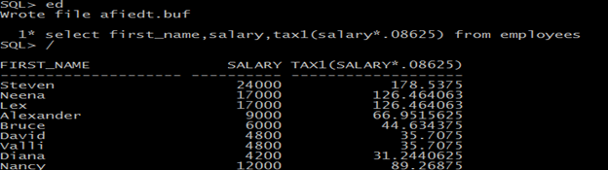

25. Write an Insert Trigger for employees’ table
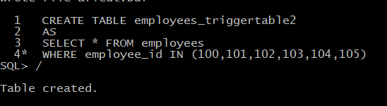
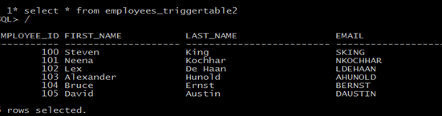
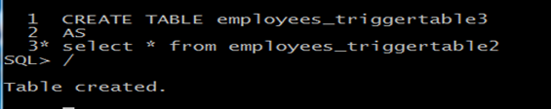
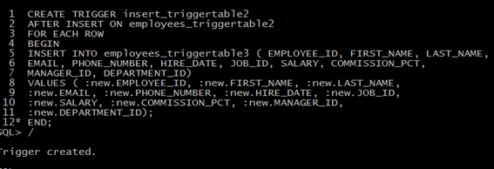
26. Write an Update Trigger for employees table
27. Write a Delete Trigger for employees table
28. Write a procedure which raises employee's salary up to 10%
29. Create a view for employees Name and Phone Number from employees Table
30. Create and account with [your name] and assign all those privileges.

